Intepret a Data Visualization

Linkedin Top Skills for 2016

Introduction:

This data is a visualization that was created from Linkedin’s list of skills that are most sought after by employers, then categorized by 14 different countries and their rank for each skill accordingly. The goal is to find three insights from this data then report it in writing with supporting explanations and screenshots found from the dashboard provided by Linkedin.

**Insight #1: Statistical Analysis and Data Mining is the only skill that has presence in all 14 countries.**

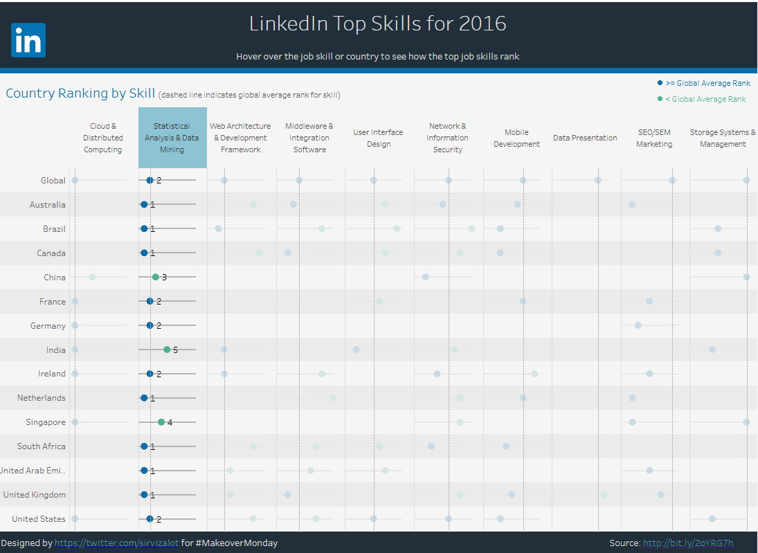

In the image above, the highlighted column is statistical analysis and data mining, which has a rank for each row, making it the only skill that has a ranking from each country. I was surprised by this fact, as I thought that every country would have entries into this dataset as they are all developed countries. But it seems statistics and data analysis is essential as each country except for China, India, and Singapore has above average ranking in this category.

**Insight #2: The United States has the most categories for in demand skills.**

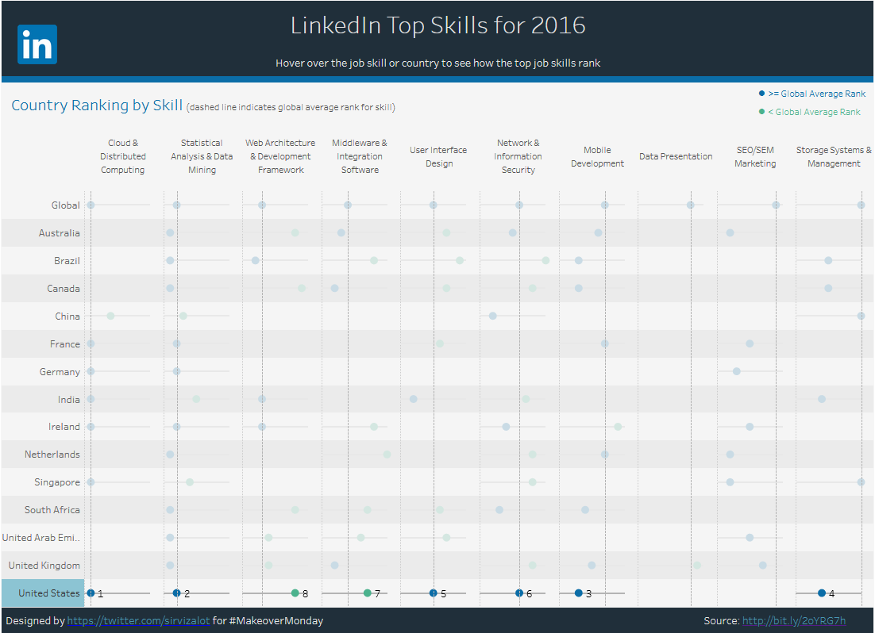

In the screenshot above, United States has a ranking in almost all categories except for Data Presentation and SEO/SEM marketing. The US has rankings that is at least average in 6 of the 8 categories, which is not surprising as many of the world’s most well-known and largest tech companies, such as Microsoft, Apple, Facebook, Cisco are all US originated companies.

**Insight #3: China has presence only in 4 out of 10 categories**

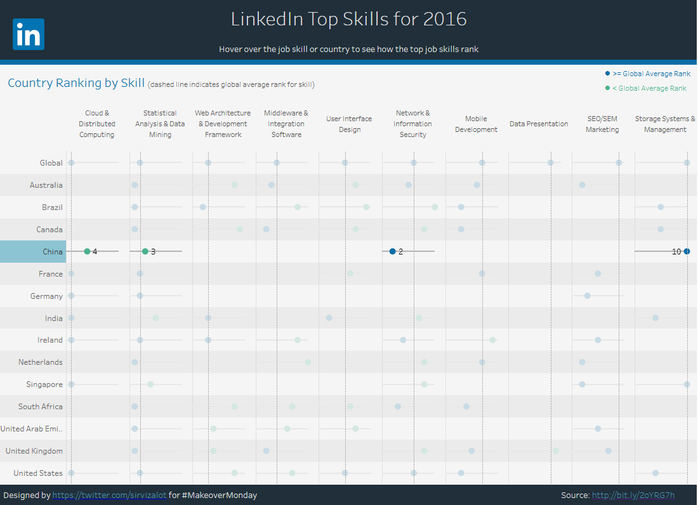

Even though this survey is from 2016, which is 4 years ago, it seems odd that China would be missing in many categories. Currently, they are the world’s 2nd largest GDP and has many sizeable tech companies that may rival US based companies. Yet they are missing in many of the categories within this dashboard. This may be due to control of their data and they did not provide enough information for this. However, I would assume that they would be at least comparable to other countries such Germany, France, and United Kingdom in terms of presence in these categories.

Conclusion

This dashboard was easy to read and understand. All these countries seem to diff greatly in terms of ranking in each category. Some things were predictable such as the US ranking near the top for almost every category, while some things were surprising such as Brazil and South Africa having presence in more categories than China. Some skills were predictably well represented such as statistical analysis and data mining, and mobile development. However, some categories were surprisingly missing from countries, such as user interface design in Singapore. Overall, the data was well represented, and the surprising facts may be due to lack of reporting from the countries.

References:

https://public.tableau.com/profile/matt.chambers#!/vizhome/LinkedInTopSkills2016-MakeoverMonday/LinkedInTopSkills2016-MakeoverMonday